Healthy Food For Eyes
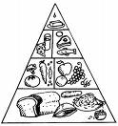

Module 1 Eye Health

Look through some different magazines. Cut out pictures of foods that you see. Decide if they are healthy or unhealthy for your eyes. Using glue, paste each picture under the `unhealthy` or `healthy` category that you think is correct.

Foods That Are Healthy For My Eyes | Foods That Are Unhealthy For My Eyes
Alternatively to using magazines to find pictures of food, use the pictures below .

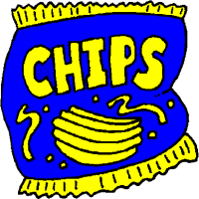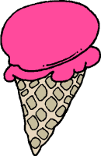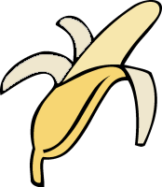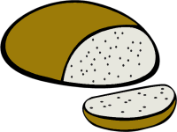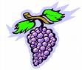

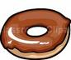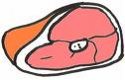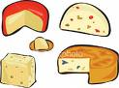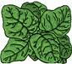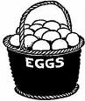

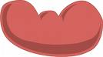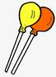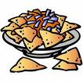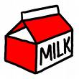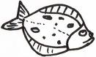

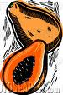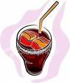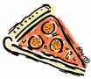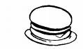

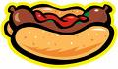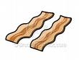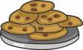

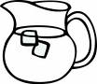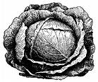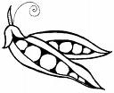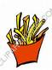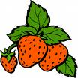

© 2007 Association for the Blind of Western Australia
Exceptions: Images
© Microsoft Office Clip Art

